Understanding and Combating Far-Right Extremism and Ultra -Nationalism in Georgia

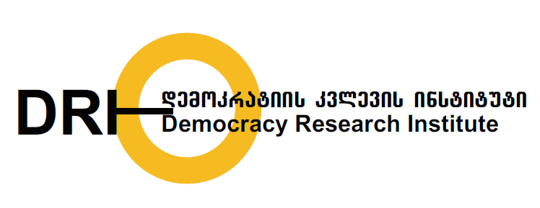

Social media monitoring results

Second quarterly report

(September-November 2019)

The media monitoring report was prepared by the Democracy Research Institute (DRI) within the framework of the project "Understanding Far-Right Extremism and Ultra-Nationalism in Georgia". The project is financially supported by the Embassy of the Kingdom of the Netherlands. The views and opinions expressed in this publication belong to the team of the project and should not be perceived as an official opinion of the Embassy of the Kingdom of the Netherlands.

Data processing and media monitoring: Ketevan Murgulia

Persons responsible for the publication: Ucha Nanuashvili, Tamar Khidasheli

Democracy Research Institute

www.democracyresearch.org
E-mail: info@democracyresearch.org

2019

Contents

Brief Dictionary of Terms 4

Introduction 5

1. Methodological Framework 6

2. Key messages of far-right discourse in online media 9

2.1. Pro-Russian Discourse in Online Media 9

2.2. Anti-liberal Discourse in Online Media 16

3. Facebook Discourse of far-Right Groups and Their Leaders 18

3.1. effects of nationalist sentiments in far-right discourse 19

3.2. Anti-liberal rhetoric in Georgian far-right groups 21

4. Key findings of media monitoring 24

Brief dictionary of terms

Discourse - shared models of meanings that give specific meanings to social objects.

Far-right ideology - an ideology that combines racism, xenophobia, misogyny, anti-Semitism and homophobia.

Discourse analysis - a qualitative research method that involves detailed analysis of textual material. It also describes socio-cultural context and assigns specific meanings to social objects.
- Far-right groups – the groups that promote anti-liberal and anti-Western sentiments. In addition, their rhetoric is sharply homophobic, xenophobic and nationalist.
- Extremism - an ideology that does not recognize the idea of ​​human equality, incites hatred, violence and intolerance.
- Anti-Western discourse - identifying and analyzing sharply negative attitudes towards the EU, North Atlantic Alliance and Western countries.
- Anti-liberal discourse - identifying and analyzing the cases of demonization of liberalism and degradation of liberal values.

Introduction

The present study is a result of a three-month media monitoring conducted by the Democracy Research Institute (DRI), which analyzes the key characteristics of far-right discourse in social and online media from September 1, 2019 until November 30, 2019. In addition, the study indicates how often hate speech is used by far-right groups or their leaders on the social network.

The present media monitoring showed that there are many far-right groups in Georgia, which, along with similarities, have many distinctive qualities. As a general observation, it can be said that each group's political ideology is fragmented and hybrid, indicating that far-right groups in Georgia use different ideologies as a tool to attract followers. The fragmented nature of far-right groups in Georgia can be seen in the ambiguity of their action plans. In addition, their political identities are not solid and are constantly changing in light of different social events.

The political and social messages of far-right groups differ in many cases. That is why it is not justified to judge them under one umbrella and to say that the discourses of far-right groups are identical. However, when we look at the target groups who most often become victims of these groups’ aggression, we can see common signs as well. Consequently, the definition of far-right ideology within the context of the present media monitoring is as follows: an ideology that incorporates homophobia, xenophobia, racism, Islamophobia and monogamy. The term far-right' implies in the study not the political identities of these groups, but their action plans and messages.

The report describes the methodological framework of the study, identifies far-right forces and studies their rhetoric. The final section of the study summarizes the key findings identified during the media monitoring.

- Methodological framework

The main purpose of the present study is to analyze the cases of hate speech and the key elements around which the far-right discourse is formed in Georgia. Given the subject of the study, discourse analysis was chosen as the research method.

Discourse analysis made it possible to identify who is the main target of aggressive reflexes and what social and political developments serve as basis for the formation of far-right rhetoric in Georgia. Far-right groups and their leaders’ area of ​​action was identified and their Facebook's statuses were studied through content analysis. The qualitative section of the study provides and illustrates the key messages of far-right groups, their political discourse and a kind of typology of civic activities.

As part of our media monitoring, we also studied the online media and Facebook pages that actively promote far-right ideas in Georgia. Most of these pages were characterized by spreading false information and propaganda. Since some of the propaganda Facebook pages were canceled during the study, the report lists only those that were active during the period of the media monitoring and were intensively spreading far-right opinions.

The following were selected as subjects of monitoring:

- Nine Websites:
1 | Tvm.ge | https://tvm.ge/
2 | Georgia and the World | http://geworld.ge/ge/
3 | Politicano | https://www.facebook.com/PoliticanoGeorgia/
4 | Alt-Info | https://alt-info.com/
5 | Kavkazplus.ge | https://ge.kavkazplus.com/
6 | Saqinform | http://saqinform.ge/
7 | Zneoba | https://zneoba.ge
8 | Tvalsazrisi.ge | https://tvalsazrisi.ge/
9 | Sputnik Georgia | https://sputnik-georgia.com/

- Facebook pages of 15 far-right groups:
1 | Don’t Be Liberal, Think | https://www.facebook.com/dontbealiberal/
2 | Kardhu | https://tinyurl.com/y45xpde8
3 | Nationality Georgian | https://www.facebook.com/erovnebaqartveli/
4 | Georgian Page | https://www.facebook.com/QartuliGverdi/
5 | Georgian Idea | https://www.facebook.com/gaertianebaQARTULIIDEA/
6 | Anti-Paradox | https://www.facebook.com/antiparadox/
7 | Rezoni | https://www.facebook.com/rezoni/
8 | Caucasian | http://bit.do/fi2ku
9 | Liberalism, Damn You | https://www.facebook.com/DaunDeLiberalizmi/
10 | Anti-Liberal Channel 2 | https://www.facebook.com/Geo.antiliberal.Ch/
11 | World Family Congress | https://www.facebook.com/wcf10/
12 | Turkey Is Occupant | https://www.facebook.com/StopTurkishOccupation/
13 | Georgian March | https://www.facebook.com/QartuliMarshiGeorgianMarch/
14 | Geo-pepe | https://www.facebook.com/geopepe01/
15 | Anti-Liberal Club | https://www.facebook.com/ANTILIBERALURI/

3. We also observed personal Facebook pages of far-right leaders (hereinafter referred to as "leaders"). The following 12 pages were selected for the study:
1. Guram Palavandishvili | https://www.facebook.com/guram.palavandishvili
2. Alexandre Palavandishvili | https://www.facebook.com/a.palavandishvili/
3. Konstantine Morgoshia | https://www.facebook.com/konstantine.morgoshia
4. Levan Chachua | https://www.facebook.com/chachualevan1971
5. Gulbaant Rtskhiladze | https://www.facebook.com/gulbaat.rcxiladze.001
6. Beka Vardosanidze | https://www.facebook.com/beqa.vardosanidze.1
7. Zviad Tomaradze | https://www.facebook.com/ztomaradze
8. Beka Revazishvili | https://www.facebook.com/beqa.revazishvili.7
9. Nikoloz Mzhavanadze | https://www.facebook.com/nikoloz.mzhavanadze
10. Sandro Bregadze | https://www.facebook.com/sandro.breg
11. Levan Vasadze | https://www.facebook.com/wcf10/?epa=SEARCH_BOX
12. Dimitri Lortkipanidze | https://www.facebook.com/dimitri.lortkipanidze

As part of the monitoring, we examined 1749 statuses posted by 15 far-right groups on Facebook pages. In addition, 468 articles posted on 9 Internet sites were analyzed. The monitoring showed that far-right groups and their leaders actively use the social and online media platforms to share their views.

Number of statuses according to Facebook page

- Key messages of far-right discourse in online media

The far-right groups and their leaders in Georgia actively use the platform of online media and social network to spread their ideas and attract followers. Consequently, the websites that often host far-right respondents were selected as the subjects of the study during our media monitoring.

The monitoring showed that the editorial policies of the media outlets under our observation were different from each other. Their political messages and respondents' list are also different. The spread of pro-Russian ideas along with anti-Western rhetoric was evident. In addition, the media outlets under our observation often use discriminatory, hate speech material and misinformation.

  - Pro-Russian discourse in online media

The websites - Georgia and the World, Saqinform and Sputnik Georgia were distinguished by pro-Russian propaganda and Euroscepticism during the monitoring process. Advertising banners are less noticeable on their websites. The materials published on these websites are provided both in Georgian and Russian languages. The domains of Georgia and the World and Saqinform are registered under the name of Taras Gagnidze, which explains their identical editorial policies. The Russian government's another populist media outlet in Georgia is Sputnik Georgia, which is active in the online space. Its establishment is related to the name of Russian President Vladimir Putin. Sputnik was founded on the basis of the Russian state-run news agency RIA Novosti after the relevant order was issued on December 9, 2013. Its Director General, Dmitry Kisilov, is notable for his loyal attitude to Russian President Vladimir Putin. Sputnik also owns a press center that is actively used by pro-Russian and anti-Western NGOs, such as the Eurasian Choice and the Eurasian Institute.

Georgia and the World

Georgia and the World has emerged in the Georgian media as a newspaper since 2009. Its website Geworld.ge was launched in the same year. The website spreads homophobic and xenophobic materials amid pro-Russian messages. The publisher of Geworld.ge (Georgia and the World) and Saqinform, which are known for their pro-Russian discourse, is Historical Heritage, a non-commercial legal entity founded in Tbilisi in 2009 and publicly welcomed by the then Russian President Dmitry Medvedev in 2009. The website's links to Russia are also evident from the fact that Alexandre Chachia, a Moscow-based political expert, is a member of the Public Council of Historical Heritage, who received an order from Russian President Vladimir Putin in 2014 for his contribution to the friendship and cooperation with the Russian Federation. The editorial policy of the Georgia and the World is distinguished by the spread of extremely pro-Russian narratives. In this regard, it should be noted that the September 25 interview with Gulbaant Rtskhiladze, head of the EURASIA Institute, summarized the 27 years since the fall of Sokhumi and indicated the need for rebuilding ties with Russia. The same interview also included attempts to stir up anti-Turkish sentiments amid delivering pro-Russian messages.

It was also in our interest to observe how Georgia and the World covered the international conference organized by the Center for Economic Policy Research and the McCain Institute. The conference was preceded by a statement by former NATO Secretary General Anders Fogh Rasmussen. In the article published by Georgia and the World - "There will be many more provocateurs like Cramer and Rasmussen", the former NATO Secretary General’s statement is discussed in a negative context. The article delivers a message that Georgia has fully lost control of Abkhazia and South Ossetia/Tskhinvali. In addition, the attempt to discredit the North Atlantic Alliance is also evident in the same article: "If we lose Tskhinvali and Abkhazia, what do we want NATO for?"

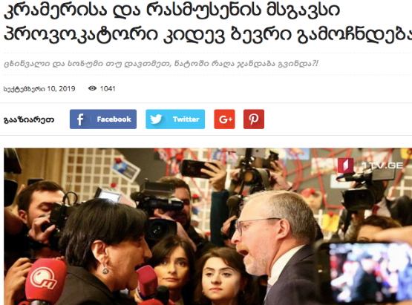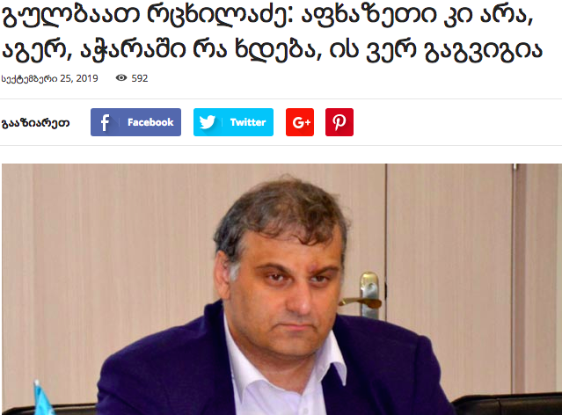

The respondents of Georgia and the World during the monitoring period were far-right politicians: Dimitri Lortkipanidze, Nikoloz Mzhavanadze and Gulbaant Rtskhiladze. Their interviews were mostly full of anti-liberal, anti-Western and homophobic messages.

Saqinform

The editorial team of Saqinform is also extremely pro-Russian. Saqinform was a news agency of the Council of Ministers of the Soviet Socialist Republic of Georgia. After Georgia gained independence, the agency was subjected to the press service of the Administration of the President. In 2004, it was abolished, but was reopened in 2010 with the same name. The owner and editor of the outlet is Arno Khidirbegishvili. He is often the author of pro-Russian articles.
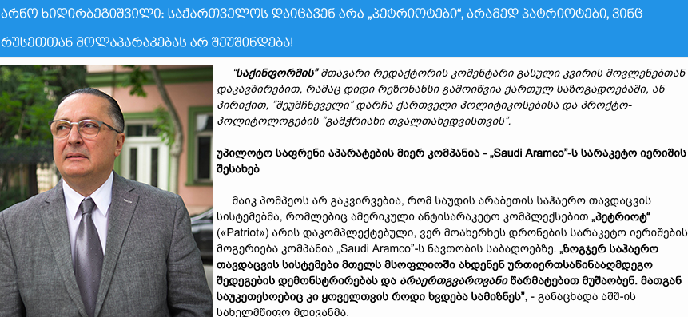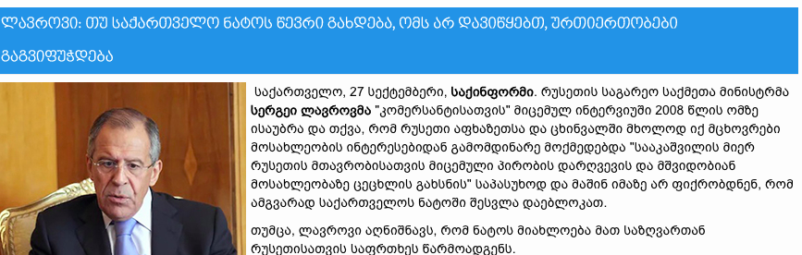

Like Georgia and the World, Saqinform spreads pro-Russian views amid of anti-Western messages. In this regard, it is particularly noteworthy how they try to discredit and demonize the United States, including by distorting facts. A conspiratorial article published by Saqinform on October 11, entitled "Pentagon's biobacteriological activity - Threat to peace and security in Eurasia," cites Military-Political Analytics, a Russian-language online magazine. Saqinform has also repeatedly spread the statements of Russian Foreign Minister Sergei Lavrov on Georgia, emphasizing Russia's good neighborly attitude, restoration of air traffic and Georgia-NATO relations.

Sputnik Georgia

The editorial policy of Sputnik Georgia is extremely pro-Russian. Sputnik, with its editorial policy, is an important multimedia actor of Kremlin political propaganda, implying its diverse editorial policy. Sputnik is a foreign-language service of the Russian state-run news agency RIA Novosti and the Voice of Russia Radio. Sputnik has a separate social editorial section for Georgian-speaking citizens, where it frequently posts news about Russia's political and cultural life. Several important articles were posted on the mentioned editorial section, including about Russia’s willingness to restore the suspended air traffic with Georgia, provided that the Georgian population realize the provocative nature of the so-called "Gavrilov's night".

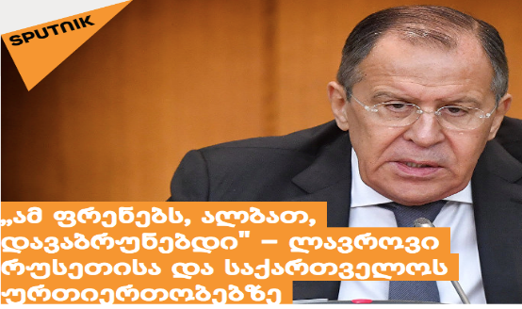

Politicano

Pro-Russian messages are circulated by Politicano’s editorial team by romanticizing the Soviet Union and spreading anti-American sentiments. The materials they publish underscore the ideal life and healthy environment of Soviet citizens and degrade liberal values. Negative sentiments are noticeable in relation to the North Atlantic Alliance as well.

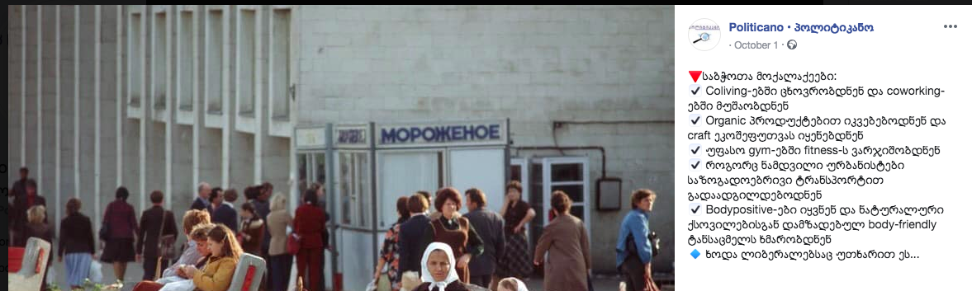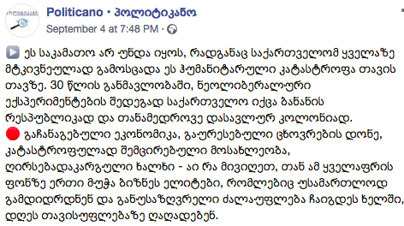

Kavkaz Plus

Another subject of media monitoring was the Kavkaz Plus website. The editorial policy of this website is extremely Armenophobic. The online outlet often publishes discriminatory and xenophobic materials against ethnic Armenians. Authors of the articles are often anonymous. The identity or domain of the website owner is not known either. Most articles cite the Russian-language and propagandistic outlets - Sputnik, regnum.ru, aif.ru, etc. The outlet, based solely on its own findings, made a conclusion about Armenian interests in Samtskhe-Javakheti and saw the threat of aggression and support for separatism behind the need to repair the Bavra-Ninotsminda road. In addition, the outlet concludes on the basis of assumptions that Armenia has an interest in the Davit-Gareji territory and seeks to take advantage of the ongoing dispute between Azerbaijan and Georgia. "The goal is clear - to fuel a conflict around the monastery between friendly states - Georgia and Azerbaijan," reads the October 30 article entitled “Armenian provocateurs continue to exacerbate the situation around Davit-Gareji."

TVMnews

TVMnews mainly spreads materials of pro-Russian and anti-Western outlets, including Saqinform, Georgia and the World and Sputnik-Georgia.

In October, the website shared the manipulative material disseminated by Alt-Info and Saqinform on Pentagon’s biobacteriological activity. The Soviet Union was romanticized in the October 23 interview with Givi Sikharulidze, who noted that "Our youth do not know what Russia is. If Russia is open, they will not want the West at all”.

An article entitled “The collapse of the Soviet Union is the greatest crime of the United States - Henry Kissinger is disappointed with capitalism” was published in October. The source of this information is the Russian-language agency panorama.pub. According to the article, the former US Secretary of State criticizes capitalism and praises the Soviet Union :“I think new persons were indeed born in the Soviet Union, which might be called - homo soveticus. These persons were on a level above us and I sincerely regret that we destroyed this treasure. It might be our biggest crime.” It should be noted that Kissinger's interview is false and was spread by ProgressNews as well, based on a Russian satirical outlet.

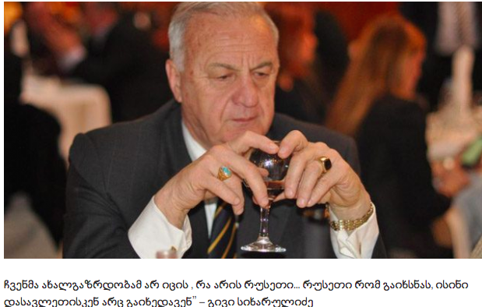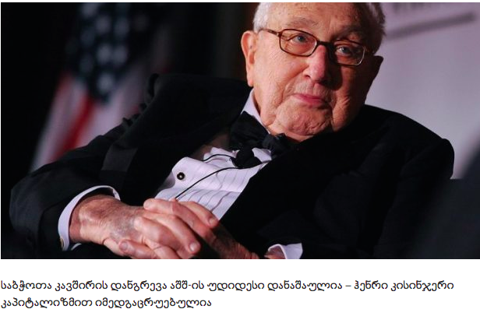

Anti-liberal discourse in online media

Alt-Info

The editorial team of Alt-Info is particularly active in spreading misinformation. Their lies and manipulations have repeatedly been exposed. One of the founders of Alt-Info is Konstantine Morgoshia. He and his teammates actively support businessman Levan Vasadze.

The editorial policy of Alt-Info is characterized by a strongly ethno-nationalist spirit. Their video and photo materials are often shared by various far-right Facebook pages. The editorial team of Alt-Info shares far-right, conservative views and its rhetoric is often based on President Donald Trump, French right-wing Nationalist Assembly leader Marion Le Pen and former Italian Foreign Minister Matteo Salvini. The editorial policy of Alt-Info clearly discredits migrants on the basis of their religious beliefs, skin color and ethnicity. Aggression is mainly directed against the followers of Islam and migrants from Africa, Asia and the Middle East. The anti-immigration discourse of the editorial team of Alt-Info, in addition to referring to the rhetoric of far-right leaders, is often “based” on suspicious surveys and statistics referring to the economic loss suffered by various European countries due to migrants. In addition, examples of France, Germany and Sweden are provided to show the negative attitudes of the local population towards migrants. Portraying migrants as an enemy creates fertile ground for fueling xenophobic and anti-immigration sentiments in Georgia.

For example, in September, Alt-Info published four articles about the persons detained for smuggling a particularly large amount of drugs into Georgia. The articles, citing official information from the Ministry of Internal Affairs, highlighted the nationality of the detainees. Two Turkish citizens, an Iranian citizen and a South African citizen were arrested.

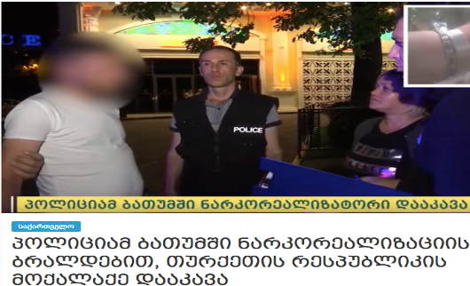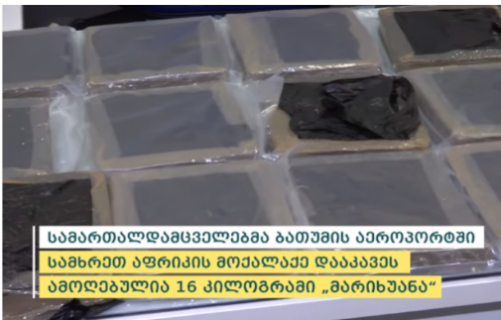

Zneoba

The Zneoba website is distinguished by its homophobic messages. Liberalism is identified with hostility to Christianity, filth and LGBT propaganda. On November 21-22, Davit Lortkipanidze, a representative of the Zneoba Youth Center, together with Guram Palavandishvili, Chairman of the Society for the Rights of the Child, held rallies against the Council of Europe-supported campaign “I Choose Equality”. Their main messages were directed against the LGBT community, feminists and liberals. An article entitled "No gender at school - Our children are at risk" was published on the website on November 20. The article emphasized that liberals support LGBT propaganda and pedophilia.

Manipulating children and discrediting liberalism distinguishes the Zneoba team from the homophobic and anti-liberal discourse of other online websites. Pseudo-religious factors prevail in their editorial policy. The article published on September 22 indicates how the former Orthodox Church has became a "sodomy club." The Code on the Rights of the Child adopted by the Georgian Parliament is regarded as a “perversion of children” and the UN – as a "supporter of perversion". "So they say that our children must be brought up on the ideals of the UN Convention on the Rights of the Child, namely the ideals of an organization that promotes abortions and sodomy worldwide," reads the September 24 article.

Facebook discourse of far-right groups and their leaders

The far-right groups and their leaders in Georgia use Facebook to share their views and attract followers. The anti-liberal discourse of far-right groups and their leaders mainly involves demonizing and discrediting the liberal West, as well as spreading xenophobic and homophobic narratives, along with the rhetoric of “protecting” national traditions, values and cultural identity.

Different far-right groups and their leaders have different discourses. Their attitudes towards Russia and the West are also different. More specifically, one part of the far-right groups and leaders continuously focus on nationalist narratives and thus explain their anti-liberal attitudes, while the xenophobic or homophobic views of another part of far-right groups and their leaders are a direct reflection of the Russian propaganda. Accordingly, within the framework of our media monitoring, we separated the discourses of various far-right groups and their leaders and studied their historical context.

In October, far-right forces - Georgian March and supporters of Levan Vasadze - opposed each other. Anti-Paradox accused Beka Revazishvili, leader of the youth wing of the Georgian March, of conducting a negative campaign against Levan Vasadze and described the farcical statuses about Levan Vasadze posted on the Eminence Grise page as statuses ordered by Sandro Bregadze. In a post published on October 30, the Alt-Info team and activist Beka Vardosanidze were described as Levan Vasadze's "sheep". Beka Revazishvili is the administrator of Eminence Grise.

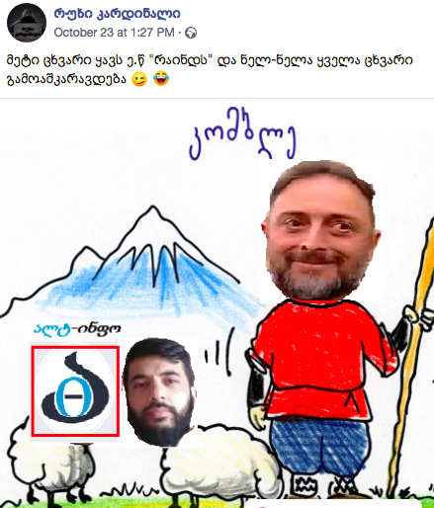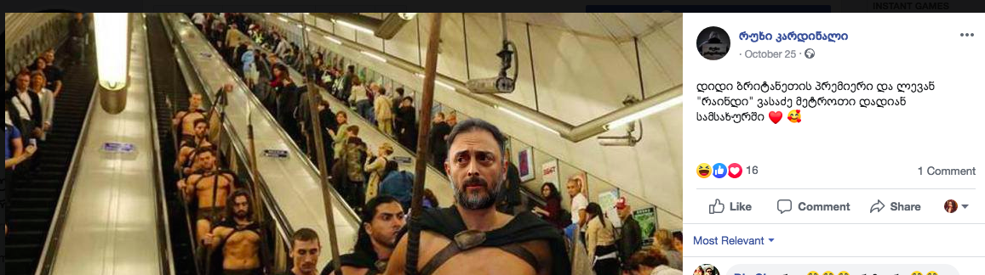

Nationalist sentiments in far-right discourse

Focusing on national values ​​and traditions is characteristic of extremist groups and Facebook pages, such as Caucasian, World Family Congress, Georgian Idea, Georgian March, Kardhu, Turkey Is Occupant and Nationality Georgian. National issues are the background of their xenophobic and homophobic rhetoric.

Georgian Idea

Georgian Idea is a public political movement, which was founded in 2014 and has a Facebook page with the same name. The leader of the movement is Levan Chachua, who was released under the status of a political prisoner on January 13, 2013. Chachua was also a member of the Orthodox Parents' Union. Religion is a powerful tool in his far-right discourse. In this case, the spread of nationalist narratives is linked precisely to Christianity.
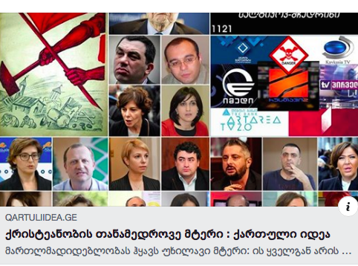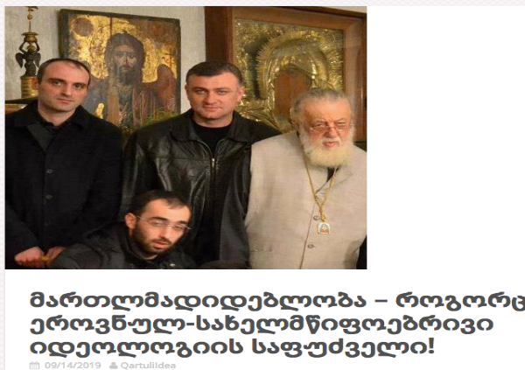

The movement leaders and members often hold demonstrations and rallies and are characterized by xenophobic and homophobic rhetoric. The name of another leader, Guram Palavandishvili, who is one of the members of the committee, is also linked to the above far-right group. In addition, Palavandishvili is also Chairman of the Society for the Rights of the Child. In September, Levan Chachua and Guram Palavandishvili, together with two other far-right activists - Aleksandre Palavandishvili and Gega Khvedelidze - collected signatures against "LGBT perversion and anti-discrimination law". On November 21-22, Guram Palavandishvili organized rallies in front of the Academy of the Ministry of Internal Affairs, European School, Council of Europe Office and Open Society Georgia Foundation. The rallies were directed against the CoE-backed "I Choose Equality" campaign and were of homophobic content. Demonstrators called the campaign an "LGBT propaganda week" and urged the State not to allow "propaganda of LGBT perversion" in schools. Demonstrators also strongly protested against the employment of individuals with NGO work expertise in public service.

Kardhu

Another far-right group, Kardhu, was registered in 2016 to promote nationalism and patriotism. Protecting the Georgian language and strengthening the national forces are the main goals of the group. The group is distinguished by its xenophobic discourse. Their posts are often anti-Turkish.

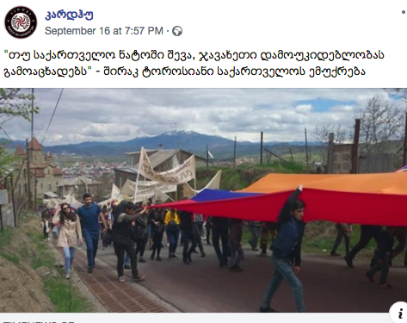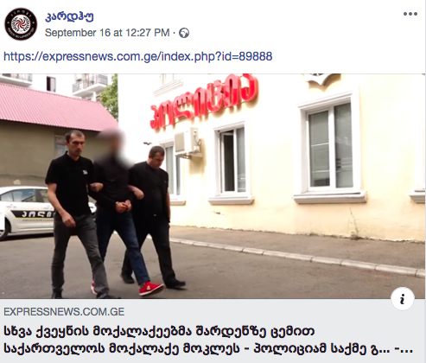
Turkey Is Occupant

Turkey Is Occupant is a strongly anti-Turkish page. One of the statuses posted in September stresses that Batumi no longer looks like a Christian city due to influence of Turkey, while another post points out that "The flags of both Georgia and Turkey hoisted at the police station being constructed at the entrance of Bakuriani provide grounds for concern for Georgia." The page constantly emphasizes the threat of occupation of Adjara by Turkey, portraying Turkey as an occupying country that endangers Georgia as well. The page responded sharply negatively to the celebration of the 96th anniversary of the foundation of the Republic of Turkey in Batumi. “Batumi is becoming Turkey and Georgians cannot realize it”, reads the article.

  - Anti-liberal rhetoric in Georgian far-right groups

Facebook pages, such as Liberalism, Damn You, Anti-Liberal League, Do Not Be Liberal, Think and Anti-Liberal Channel 2 mainly publish homophobic and xenophobic narratives and portray liberalism as the main enemy of mankind and a source of perversion. The Alt-Info team can be considered as an ideologue of these pages. Most often, materials posted on these pages are shared from the Alt-Info news site.

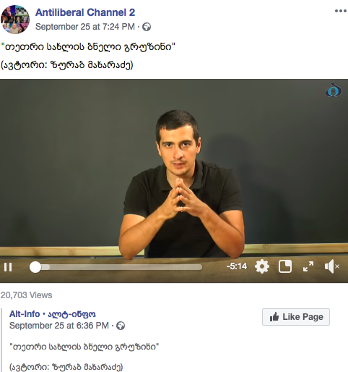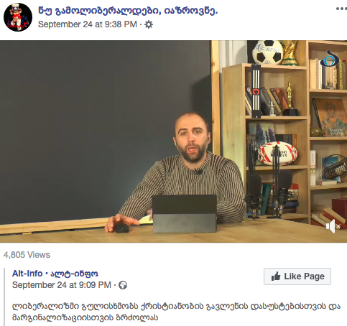

Far-right activist Beka Vardosanidze is distinguished by his anti-liberal rhetoric. According to him, he relies on the conservative views and ideology of President Donald Trump, Hungarian Prime Minister Viktor Orban and former Italian Foreign Minister Matteo Salvini.

The anti-liberal discourse of the Geo-pepe, Anti-Paradox and Rezoni Facebook pages is often misogynistic and homophobic. The media monitoring also showed a tendency that far-right groups often develop and disseminate common discrediting messages. These far-right groups had common messages on the following issues: 1) the case of Tamta Todadze; 2) the premiere of And Then We Danced queer movie; 3) November protests.

The far-right groups showed interest in the reports spread on October 5 that the Georgian Dream member of Tbilisi City Assembly, Ilia Jishkariani, was accused by his aide Tamta Todadze of sexual harassment and rape attempt. Later, Tamta Todadze was declared a victim by the investigative authorities. In response, a campaign was launched against Tamta Todadze in social media, and the Facebook pages of far-right groups - Anti-Paradox, Kardhu, Geo-pepe and Georgian Page - were actively involved in it. The pages spread several messages of different contents, the aim of which was to defend the member of the City Assembly and to discredit Tamta Todadze. Media outlets loyal to the government - Pirveli news agency and Plus.kvira.ge - also reported identical information against Tamta Todadze.

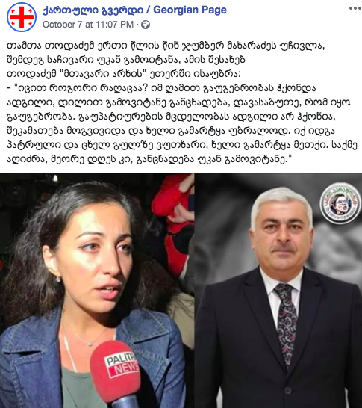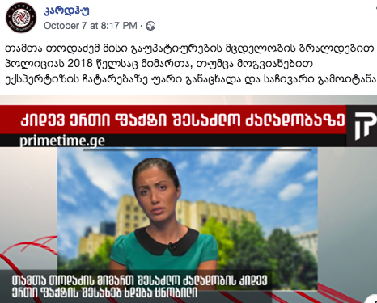

The second major issue which demonstrated links between the far-right groups was the homophobic campaign against And Then We Danced movie. On November 3, Sandro Bregadze, leader of the Georgian March, posted a status on his Facebook page: "Do not allow propaganda of this filth." His statement was directly shared by Saqinform, Alia and Tvalsazrisi. Like the case of Tamta Todadze, one of the important messages of far-right forces was to link the filmmakers with the National Movement.

Sandro Bregadze called the premiere the "propaganda of filth," "sodomy" and " premiere of homosexuality" and a move against Georgian traditions. Sandro Bregadze's idea of ​​disrupting the premiere was supported on November 5 by far-right leaders and activists, such as Guram Palavandishvili, Levan Vasadze, Beka Vardosanidze, Levan Chachua and Dimitri Lortkipanidze. Guram Palavandishvili said at a press conference in the Kvira media center that they would picket cinemas and the audience would not be allowed to enter the buildings. Like Sandro Bregadze, his rhetoric was also homophobic when describing the film. Dimitri Lortkipanidze, chairman of the Primakov Foundation, described the film as "an attempt to stain the most sacred event by the sodomy sin." On November 4, he posted a status on his Facebook page: "Apparently, Sweden does not fund only NDI surveys and now they have found a way to offer apologia of sodomy through cultural intervention."

The November protests was the third major event opposed by the far-right groups. Facebook pages, such as Kardhu, Fifth Column, Don't Be Liberal, Think, Georgian Page and Geo-pepe disseminated misinformation against the protests and discredited its organizers by linking demonstrators with the National Movement. Representatives of the Georgian Dream also had the same message. Sharply pro-Russian media outlets, Georgia and the World and Saqinform, also responded to the rallies and identified the organizers and activists with the National Movement. The resemblance of messages of far-right forces, pro-Russian media outlets and the authorities raises suspicions about their coordination.

- Key findings of the media monitoring

- Far-right groups often use fake surveys and unverified information in online media;

- Leaders of far-right groups use social networks to mobilize supporters for protests; they mainly use Facebook to plan rallies and disseminate information;

- Conflicts between far-right forces are common;

- The far-right discourse in social and online media is characterized, on the one hand, by ethno-nationalist, and on the other hand, by strongly pro-Russian messages;

- The role models of the Alt-Info team, which is an active supporter of businessman Levan Vasadze, are President Donald Trump, French Nationalist Assembly leader Marion Le Pen and former Italian Foreign Minister Matteo Salvini.

Note: These definitions of the terms are not universal and were developed for the purposes of the present study.
Macridis, Roy C. Contemporary Political Ideologies: Movements and Regimes, 4th ed. Glenview: Scott, Foresman and Co., 1989, pg. 231
Levan Vasadze does not have a personal Facebook page, though his messages can be studied on the World Family Congress Facebook page, which actively shares his video addresses.
Kintsurashvili, T. (2019), Anti-western Propaganda 2018, pg. 51-52, available at: http://mdfgeorgia.ge/uploads/library/119/file/AntiWest-2018-GEO.pdf
Myth Detector, December 2, 2019. “Pro-Russian and anti-Western messages in the Sputnik-ossetia and Sputnik-Abkhazia materials”, available at: http://bit.do/fnpHT
JAMNEWS, 6 December, “By whom and how the Kremlin messages are spread in Georgia”, available at: http://bit.do/fnpFh
JAMNEWS, 6 December, “By whom and how the Kremlin messages are spread in Georgia”, available at: http://bit.do/fnpFh
Dzvelishvili, N. Kupreishvili, T. (2015). “Russian influence on Georgian NGOs and media”, pg. 10-11, available at: https://idfi.ge/public/upload/Meri/Russian%20Influence%20on%20NGOs%20and%20Media.pdf
Dzvelishvili, N. Kupreishvili, T. (2015). “Russian influence on Georgian NGOs and media”, pg. 11, available at:https://idfi.ge/public/upload/Meri/Russian%20Influence%20on%20NGOs%20and%20Media.pdf
Georgia and the World, September 25 - "Gulbaat Rtskhiladze: “We are not even aware of what is happening here, in Adjara, not to say Anything about Abkhazia", available at: http://bit.do/fnpNC
By this statement, Anders Figh Rasmussen offered the Georgian authorities to consider joining the North Atlantic Treaty Organization without Article 5 applying to Abkhazia and South Ossetia.
Georgia and the World, September 10 - "There will be many more provocateurs like Cramer and Rasmussen", available at: http://bit.do/fnpRK
Georgia and the World, October 30 - Dimitri Lortkipanidze: ““Educational” programmes for elementary school students will be launched in the near future, so that children are taught and inspired by some "liberal" standards from an early age”, available at: http://bit.do/ffPJi
Georgia and the World, October 9 - "Nikoloz Mzhavanadze: Unless a real national force is formed, its place will probably be occupied by 'liberal' forces and people will have to choose between the bad and the worse“, available at: http://bit.do/ffPNH
Georgia and the World, November 20. – “Gulbaat Rtskhiladze: This protest is a revenge attempt by aggressive political forces”, available at: http://bit.do/firVn
Myth Detector, 2 December 2019. Saqinform news agency, available at: https://www.mythdetector.ge/ka/profile/sakinpormi
Dzvelishvili, N. Kupreishvili, T. (2015). “Russian influence on Georgian NGOs and media”, pg. 16, available at: https://idfi.ge/public/upload/Meri/Russian%20Influence%20on%20NGOs%20and%20Media.pdf
Media profiles, Saqinform, source: http://mediameter.ge/ge/media-profiles/sakinpormi, last accessed on November 30, 2019.
Saqinform, September 23 - “Arno Khidirbegishvili: Georgia will be protected not by“ Petriots” but by Patriots, who will not be afraid to negotiate with Russia!”, available at: https://tinyurl.com/yxd2vpbj
On October 10, an article on former US State Department official Matthew Bryza was posted on the Alt-Info page regarding Georgia's eventual loss of territories. "Matthew Bryza: Russia will never leave it" reads the headline of the article. Matthew Bryza's words were taken out of the October 8 interview with the Ukrainian Espresso TV channel. Alt-Info and Saqinform distorted facts and used quotes out of context.
Saqinform, October 11, "Pentagon’s biobacteriological activity - Threat to peace and security in Eurasia", available at: http://bit.do/ffJDU
Military Political Analytics, September 28, - " Pentagon’s biobacteriological activity - Threat to peace and security in Eurasia", available at: http://bit.do/ffJHz
Saqinform, September 27, "Lavrov supports restoration of air traffic with Georgia", available at: https://tinyurl.com/y6xsu77n
Saqinform, September 27, - "Lavrov: If Georgia becomes NATO member, we will not start a war, but relations will be worsened", available at: https://tinyurl.com/y4flbz7p
Liberal, May 20, Sputnik is a foreign-language service of the Russian state-run RIA Novosti news agency and the Voice of Russia radio, available at: http://liberali.ge/news/view/16553/sputnikis-vebgverdis-qartulenovani-versia-amoqmedda
Sputnik Georgia, September 27, "Moscow hopes for the restoration of direct air traffic with Georgia", available at: https://tinyurl.com/y5hr9g9z
Politicano, October 1, "Soviet Citizens", available at: http://bit.do/ffPVo
Politicano, September 17 - "The NATO Secretary General, after so long, has the audacity to make such cynical statements", available at: https://tinyurl.com/y2bd7mc2
Mediachecker, August 15, - "Armenophobic texts on Kavkaz Plus", available at: http://bit.do/fnrHg
Kavkaz Plus, October 30, - "Armenian provocateurs continue to fuel the situation around Davit-Gareji", available at: http://bit.do/ffQaS
Tvm.ge, October 23, - "Pentagon’s biobacteriological activity - Threat to peace and security in Eurasia", available at: http://bit.do/ffQdj
Tvm.ge, October 23, “Our youth does not know what Russia is. If Russia is open, they will not want the West at all", available at: https://tvm.ge/archives/24297
Tvm.ge, October 23, "The collapse of the Soviet Union is the greatest crime of the United States - Henry Kissinger is disappointed with capitalism", available at: http://bit.do/ffQex
Tvm.ge, October 23, "The collapse of the Soviet Union is the greatest crime of the United States - Henry Kissinger is disappointed with capitalism", available at: http://bit.do/ffQex
Myth Detector, October 22, "Kissinger's interview on USSR is false and was disseminated by ProgressNews based on the Russian satirical outlet", available at: http://bit.do/fnrsp
FactCheck - Alt-Info Media Group, available at: http://bit.do/fnrNw
Myth Detector, January 9, “Material about Russia's false information danger is no longer available due to Alt-Info’s censorship", available at: https://tinyurl.com/y5n2jdng
Alt-Info, September 24, "Trump: If you want peace, love your nation; The future doesn't belong to globalists, the future belongs to patriots", available at: https://tinyurl.com/y4zpqd5a
Alt-Info, September 22, "Marion Le Pen and Matteo Salvini demand referendum on immigration", available at: https://tinyurl.com/yxw8rygh
Alt-Info. September 28, "According to the recent new poll, Matteo Salvini enjoyes the highest confidence in Italy", available at: https://tinyurl.com/y6y4hna8
Alt-Info, September 18, "Immigration from Europe cost British people £ 3m a day", available at: https://tinyurl.com/y2bvbrd6
Alt-Info, September 12, “France spends € 2 billion on juvenile migrants every year”, available at: https://tinyurl.com/y3m86px5
Alt-Info, September 3, ”Research: Most Germans think immigration rate is too high”, available at: https:https://tinyurl.com/yydsn4vy
Alt-Info, September 2, "Locals are fleeing the Swedish municipality after it gets full of migrants, due to which, the country faces the danger of budget crisis", available at: https://tinyurl.com/y2n6nlsu
Alt-Info, September 23, - "Police arrest a citizen of the Republic of Turkey on drug charges in Batumi", available at: https://tinyurl.com/y562q58h
Alt-Info, September 25, "MIA detained a citizen of the Republic of Iran for possession of a large amount of drugs - 3 kg of heroin was seized", available at: https://tinyurl.com/y638cpql
Alt-Info, September 24, - "MIA arrests a South African citizen on drug charges in Georgia - 16kg of marijuana was seized“, available at: http://bit.do/fnrYu
Zneoba, November 20, "No gender (LGBT) in kindergartens and schools!", available at: http://bit.do/fiwZq
Zneoba September 22, "The Orthodox Church turned into a sodomy club", available at: https://zneoba.ge/5497/
https://www.facebook.com/qartuliidea.ge/
Myth Detector, Georgian Idea. https://www.mythdetector.ge/ka/profile/kartuli-idea
On.ge, October 4, - “Georgian Dream member and Tbilisi City Assembly Deputy was accused by his employee of rape', available at: http://bit.do/ffQLw
Saqinform, November 4, "We should in no way allow the premiere of this horror! - Sandro Bregadze about the Georgian gay movie", available at: http://bit.do/ff5ZT
Alia, November 3, - “We should in no way allow the premiere of this horror! - Sandro Bregadze about the Georgian gay movie", available at: http://bit.do/ff53j
Tvalsazrisi, November 3, "We should in no way allow the premiere of this horror! - Sandro Bregadze about the Georgian gay movie", available at: http://bit.do/ff52L
First Channel, November 5, - "Guram Palavandishvili and Dimitri Lortkipanidze say they will not let people enter cinemas for the premiere of And Then We Danced movie”, available at: http://bit.do/fnrwq

